ICEcore User Guide
1.0 Concepts and Navigation
1.1 ICEcore is Collaboration Software
1.1.1 ICEcore is Knowledge Management Software
1.2 Navigating Workspaces and Folders
1.2.1 The Default Portlets
1.2.2 The Navigator Portlet
1.2.3 Viewing a Workspace or Folder
1.2.4 Using More Navigational Tools
1.2.5 Returning to the Portal Page
1.3 Using Help Mode
1.3.1 Help for Administrators
2.0 Getting Started
2.1 Set Up Your Buddy List
2.2 Modify Your Personal Workspace
2.2.1 Add Basic Information
2.2.2 Edit Contact Information and Add Pictures
2.2.3 Add a Blog Entry
2.2.4 Collaborate with Others
2.3 Create a Team Workspace
2.3.1 Create the Workspace
2.3.2 View Team Members
2.3.3 Communicate with Teammates
2.3.4 Allow Visitors to Your Team Workspace
2.4 Use Advanced Search to Explore
2.5 Use the Workspace Tree to Explore
3.0 Features Overview
3.1 Tools
3.1.1 Accessories
3.1.2 Favorites
3.1.3 Tags
3.1.4 Filters
3.1.5 E-mail Notifications
3.1.6 The Clipboard
3.1.7 Entry-Reference Mark-Up
3.1.8 Rating Stars
3.1.9 Workflow
3.1.10 ICEcore Conference
3.1.11 Accessibility Mode
3.2 Folder Types
3.2.1 Blogs
3.2.2 Discussions
3.2.3 Calendars
3.2.4 Guestbooks
3.2.5 File Folders
3.2.6 Milestone folders
3.2.7 Photo Albums
3.2.8 Surveys
3.2.9 Tasks
3.2.10 Wikis
3.3 Workspaces
3.3.1 Global Workspaces
3.3.2 Personal Workspaces
3.3.3 Team Workspaces
3.3.4 Project Workspaces
A.0 Troubleshooting
A.1 WebDAV Link Does Not Work
A.2 Too Many Sign Ins for WebDAV
A.3 Not Understanding Mirrored Folders
Glossary
B.0 Legal Notices
This manual provides getting-started information for new users of ICEcore.
This manual presents more detailed descriptions of the information found in the ICEcore Quick Start Guide, including more pictures.

Audience
This guide is intended for all new ICEcore users.

Software and Documentation Version
This manual describes features in ICEcore Version 1.0. This is Version 1.0 of this manual.

Contents of this Manual
This manual provides information about the following:
- Concepts and navigation
- Getting-started procedures
- Feature overview
- Glossary
- Troubleshooting

Conventions
This manual uses the conventions described in the following paragraphs and table.
A greater-than symbol (>) is used to separate actions within a step and items in a cross-reference path.
A trademark symbol (®, ™, etc.) denotes a SiteScape trademark. An asterisk (*) denotes a third-party trademark.
When a single pathname can be written with a backslash for some platforms or a forward slash for other platforms, the pathname is presented with a backslash. Users of platforms that require a forward slash, such as Linux or UNIX, should use forward slashes as required by your software.
What you see | What it means
Click the Add a team workspace button.  Click the Getting Started link. | Items that are clickable on the page are presented in italic font.
Blog summary - Provides a....  Note: Remember that.... | Defined terms in a list and note headers are presented in bold font.
Type status, then press Enter.  Open the ManagerGuide.pdf file. | Text that you must type and file names are presented in Courier font.

Additional Documentation
You can find more information in the ICEcore documentation, which is accessible from links within the ICEcore software:
- ICEcore Help Mode
- ICEcore Quick Start Guide
- ICEcore Installation and Configuration Guide
- ICEcore Administration Guide
This document describes how to use ICEcore Help mode, which describes product pages and tools.

1.0 Concepts and Navigation
ICEcore is collaboration software that bridges the gap between teammates working alone at their computers and working together during meetings. It provides spaces and tools for online teaming and conferencing.
This chapter provides overview information about the product and about navigating its pages. If you prefer to “learn by doing,” you may want to begin by reading the next chapter.
This chapter includes:
- Section 1.1, ICEcore is Collaboration Software
- Section 1.2, Navigating Workspaces and Folders
- Section 1.3, Using Help Mode

1.1 ICEcore is Collaboration Software
Collaboration using ICEcore facilitates online work, creating a “virtual meeting space.”
Here are examples of the increase in team synergy you experience when using ICEcore:
- You and your teammates can work together without having to be in the same room or working at your computers at the same time. Someone can post a note or document to a folder, and, at their convenience, teammates can comment on the work, review and edit files, and further develop the idea. With ICEcore, teamwork is ongoing and potentially never ending.
- When you are working online at the same time, the “presence” feature of ICEcore allows you to see which teammates are currently online, and allows you to start a chat session using ICEcore Conference, create an online meeting using ICEcore Conference, make a Skype phone call, and so on.
- Ideas are formed together, interactively, with your teammates. By the time you hold that meeting in the conference room, the team has already been a part of the formation of the idea, and teammates are more likely to understand it, buy into it, and assist with its implementation. ICEcore becomes a "pre-meeting" meeting.
- Documents are reviewed earlier in the process, allowing easier modifications and adjustments. ICEcore also makes it easier for more than one person to write a document, because of workflow processes that automate drafting and review, and because of ICEcore access control that easily designates writers and reviewers.
- Your collaborative process is preserved and publicly accessible in ICEcore. No more searching through e-mail folders in a frantic effort to "catch someone up" on a lengthy e-mail discussion. To review past discussions and decisions, or to review a previous version of a document, use the powerful search capability of ICEcore to locate historical information quickly and easily.
- Use various ICEcore tools in combination -- a milestones folder, tasks, workflow, discussions, chat, online meetings -- to track progress against goals for multiple teams working on a large project.

1.1.1 ICEcore is Knowledge Management Software
The out-of-the-box ICEcore tools alone provide powerful enhancements to online collaboration. In addition, when you use tools in combination and apply structure to content design, ICEcore becomes a powerful knowledge-management tool. Knowledge management involves the efficient development, management, access, and distribution of organizational knowledge.
Consider the following examples:
- When people use their personal workspaces to provide detailed information about themselves, the purpose of the workspace moves beyond merely contact data (phone numbers, e-mail addresses, ICEcore Conference user name, and so on). It enables searches for various subject-matter experts. Also, ICEcore analyzes its search results, telling you which people discuss your search topic the most and in which places these conversations are happening. It is easy to see pockets of expertise associated with your area of interest.
- Experts can rate entries in ICEcore using a five-star rating system (one star indicating the least impressive, and five stars being the most impressive), providing an additional tool for determining the quality of information.
- ICEcore provides tools -- wikis (information coauthored by all participants), blogs (chronological journal entries allowing for comments from readers), workflow (an online representation of a business process), and tags (categorical labels applied to items) -- which people can use to create and organize information organically, over time, in ways that map best to the team’s natural work style. Using these tools, teams literally move their business processes online and automate their work.
- ICEcore provides work-area summaries, called accessories, that provide a snapshot of a potentially large amount of information, highlighting the most relevant data. For example, the accessory can present entries submitted by an expert on a given subject matter, or it can summarize task-completion information by providing a milestones overview.

1.2 Navigating Workspaces and Folders
Your ICEcore site administrator provides you with the web address (URL) used to access ICEcore, and your ICEcore user name and password.
After you sign in, you see a portal page, as shown on the following page.
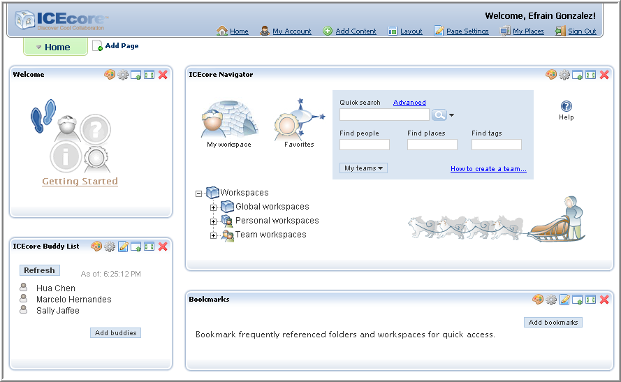
A portal page is a web page that presents different applications in sections within the larger page. On the Internet, you may have seen pages (for example, Google and Yahoo) that have sections presenting a weather report that is local to your area, stock quotes that are of interest to you, the local time, and more.
By default, ICEcore ships with LifeRay portal software. (From this point forward, references to portal features apply to LifeRay software.) Portal software contains a set of tools that allow you to create new portlets, that allow you to control the look-and-feel of the page outside of the portlets, and more. To use ICEcore, you do not have to use the portal’s tools; we recommend that you use only ICEcore tools designed to affect the look-and-feel of ICEcore information.
If your organization chooses, it can replace the default LifeRay software with different portal software. The tools provided by most portal programs are very similar. However, if your organization is using portal software other than LifeRay, and if you require additional assistance, please contact your ICEcore site administrator or your IT department for more information.
Within the portal page, separate applications can run within page sections called portlets. Here are two highlighted portlets on the portal page, as shown in the picture on the following page.
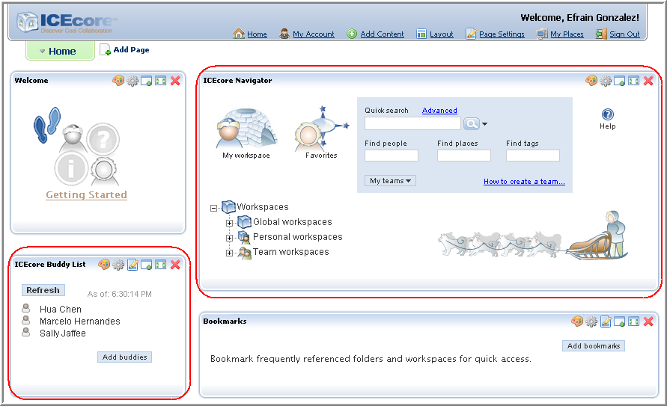

1.2.1 The Default Portlets
By default, when you sign in for the first time, ICEcore presents four portlets:
- The welcome portlet -- Provides quick access to getting-started PDF manuals (including this manual).
- The navigator portlet -- Gives you quick access to any workspace or folder you want to view in ICEcore: to your personal workspace, your favorite places, items that match search criteria, or Help for the current page.
- The buddy-list portlet -- Displays the presence of people you designate as your buddies, and provides tools you can use to contact your buddies.
- The bookmarks portlet -- Provides links to important workspaces and folders, and can provide a count of new or changed entries in folders.
ICEcore provides additional portlets that you can add to your portal page. To add another portlet, click the Add Content link, as follows:
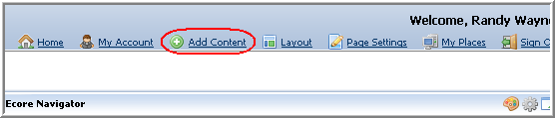
The portal software displays a list of all available portlets. Click the ICEcorelink to see a list, which includes the non-default ICEcore portlets, as follows:
- Blog summary -- Provides a snapshot of journal entries from a blog of your choice within the ICEcore installation.
- Guestbook summary -- Provides a snapshot of entries from your choice of ICEcore guest books.
- Administration tools -- Displays tools for ICEcore site administrators.
- Photo gallery -- Presents pictures from your choice of an ICEcore photo gallery.
- Search -- Presents items, potentially anywhere within ICEcore, that match search criteria.
- Wiki home page -- Displays a summary of the home page of an ICEcore wiki folder.
- Workspace tree -- Allows you to go to any place you want within ICEcore. (The navigator portlet also contains a workspace tree.)

1.2.2 The Navigator Portlet
Here is a picture of the navigator portlet:
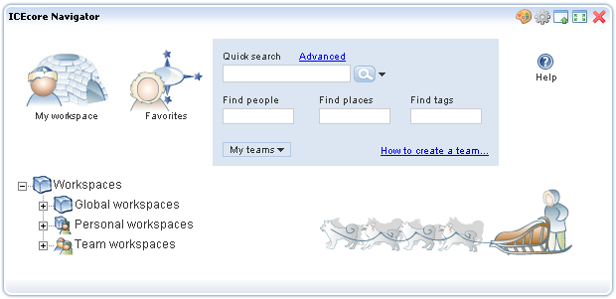
The navigator portlet provides the following tools:
- My-workspace icon -- Displays your personal workspace, which contains your contact information, pictures, a personal blog, and much more.
- Favorites icon -- Displays a tool that you can use to list links to your favorite workspaces and folders, and that you can use to access them quickly.
- Search -- Allows you to perform different types of searches, either for any items or for specific types of items (people, places, and tags, which are category labels that you can apply to items in ICEcore).
- Help -- Displays Help about various sections of the portal page, and provides access to the getting-started PDF books.
- My-teams drop-down list -- Lists links to all of the workspaces and folders in which you are designated as being a team member.
- Workspace tree -- Allows you to view any workspace or folder within the ICEcore installation. Clicking a plus sign ( +) expands a portion of the tree, and clicking a minus sign ( -) hides that portion of the hierarchy.
Notice the items in the workspace tree. By default, there are four workspaces in the tree. Workspaces are starting places for individuals and teams who want to do a certain type of work. By default, there are four organizational workspaces in the workspace tree: the Workspaces page, and subworkspaces entitled “Global workspaces,” “Personal workspaces,” and “Team workspaces.”
Global workspaces are containers for information available to anyone in your organization. Personal workspaces are pages of personal information (such as contact information, a personal blog, a personal calendar, and more) for everyone in your organization. Team workspaces are work areas designed to help small groups of people to work together efficiently and reach team goals.

1.2.3 Viewing a Workspace or Folder
There are numerous ways to view a workspace or folder in ICEcore. When getting started, the two most common methods are using the workspace tree or the search tools, both of which are located in the navigator portlet.
For example, you can click on plus sign ( +) next to the Team workspaces link in the workspace tree to see team workspaces. Using our sample installation, clicking on the plus sign next to the Team workspaces link causes the workspace tree to appear as follows:
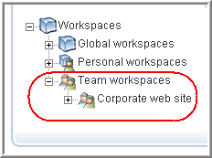
The “Team workspaces” workspace displays a single subworkspace, whose title is “Corporate web site.” ICEcore displays links only to those workspaces for which you are a team member.
Again, using our example installation, clicking on the plus sign next to the “Corporate web site” workspace title displays the contents of that workspace, as shown on the following page.
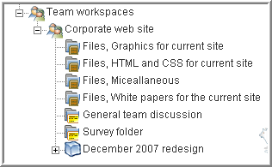
The “Corporate web site” team workspace contains six folders and a project workspace (a subsequent chapter explains these items in more detail). Folders can, in turn, contain subfolders, which further organize information. None of the folders (“Files, Graphics...,” “Files, HTML...,” and so on) in the previous picture contain subfolders; if folders have subfolders, their titles in the workspace tree are preceded with a plus sign (+).
To view a folder, click its linked title. In our example, if you open the “December 2007 redesign” project workspace and click Discussion, the project’s discussion folder appears in a maximized portal page (in which the entire page is dedicated to displaying the folder’s contents), as follows:
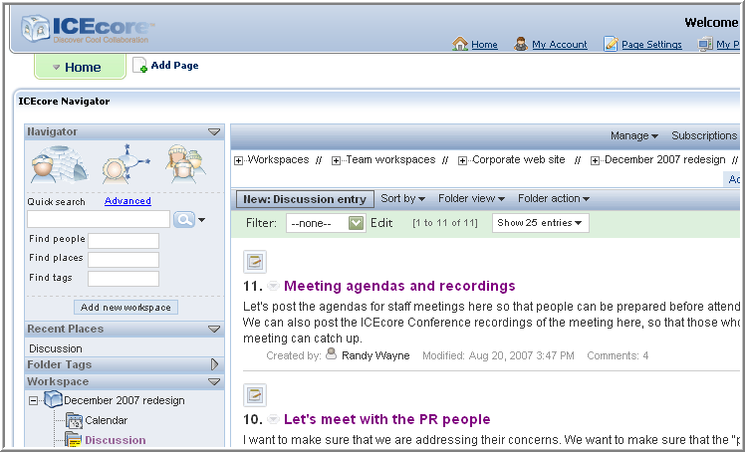
Notice that ICEcore displays most of the navigator-portlet tools in the top-left corner of a workspace or folder page, as shown on the following page.
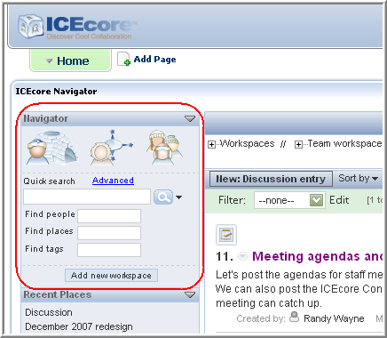
By default, a folder lists only a summary of each discussion entry. To view the entire entry, click its title:
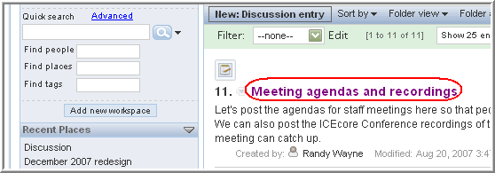
By default, ICEcore displays the discussion entry as an overlay, on top of the current page, as shown on the following page.
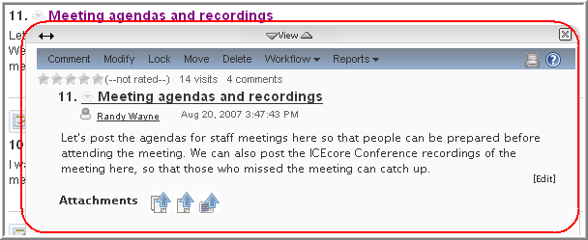
The overlay provides additional tools for reading entries. For example, you can click the Previous and Next icons to see the previous and next entries:
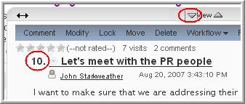
To adjust the width of the overlaid panel, click and hold the Width (double-headed-arrow) icon, move your cursor left or right, and release the click when the panel’s width is as you desire. To move the entire panel, click and hold the panel’s tool bar (which changes the cursor), and drag the panel to another position on the page. This picture shows a repositioned overlay:
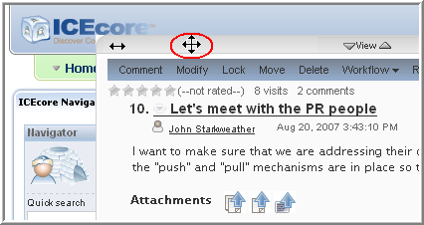
Click the Close icon ( X) in the upper-right corner of the overlay to close it, displaying only the folder listing again, as shown on the following page.
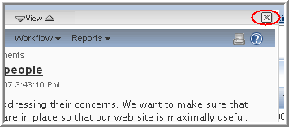

1.2.4 Using More Navigational Tools
ICEcore provides several different ways for you to go from one place to any other place within your installation, quickly and easily. For example, the previous section showed how to use the workspace tree to navigate to a team workspace page. Also in the navigator portlet, you can see a list of all the teams to which you belong:
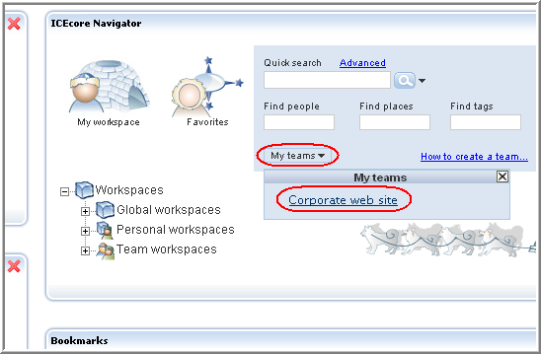
In the previous example, if you click Corporate web site, ICEcore then displays the “Corporate web site” team workspace page.
Toward the top of ICEcore pages, there is a workspace tree that shows all of the workspaces and folders that contain the currently displayed page. This type of workspace tree is often called “breadcrumbs,” which display links to all the places that precede the currently displayed place.
Consider the workspace tree at the top of the “Corporate web site” team workspace in the example shown on the following page.
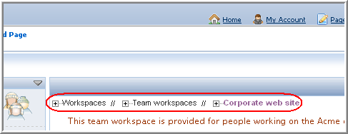
The “Workspaces” workspace contains the “Team workspaces” workspace. The “Team workspaces” page contains the “Corporate web site” team workspace.
When you are finished working with the current page, you can use this workspace tree to navigate to other places. Consider this picture.
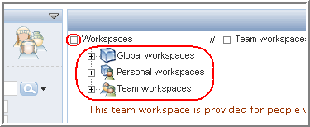
When displaying maximized ICEcore pages, such as a workspace or folder page, ICEcore includes a tools sidebar, which provides additional navigational tools, as shown on the following page.
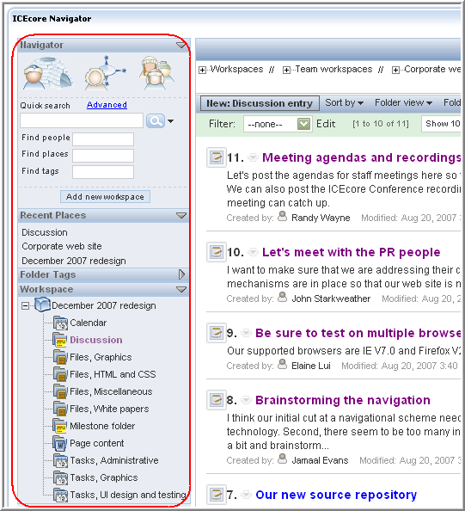
The tools sidebar for a workspace includes these sections:
- Navigator -- Provides the same features as those found in the navigator portlet, allowing you to go to your personal workspace, use links to your favorite places, go to workspaces in which you are a team member, and search.
- Recent places -- Provides links to a few of the pages you viewed recently.
- Folder tags -- Displays a list of tags that have been applied to items in the currently displayed place. Tags are category labels that you create and apply to items to make them easier to find later.
- Workspace -- Shows links to all places contained within the current workspace. Whereas the workspace tree at the top of the page shows you the path to the current place, this workspace tree provides a path to the contents of this place. In this example, the “December 2007 redesign” team workspace contains eleven folders.
The sections in the tools sidebar can vary by folder type. For example, blogs include a section that enables you to see journal entries in a previous month (the monthly list of blog entries is called an archive).
Continuing with our example, let’s say that the viewer of the “Corporate web site” team workspace wants to view the personal workspace of a coworker. First, he can type just a few letters of his coworker’s name in the “Find people” text box of the Navigator, as follows:
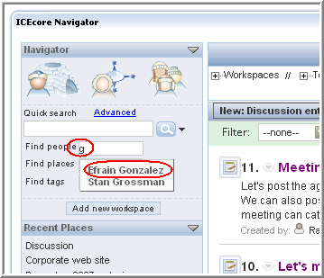
After clicking the user name of Efrain Gonzalez, ICEcore displays that person’s personal workspace, as shown on the following page.
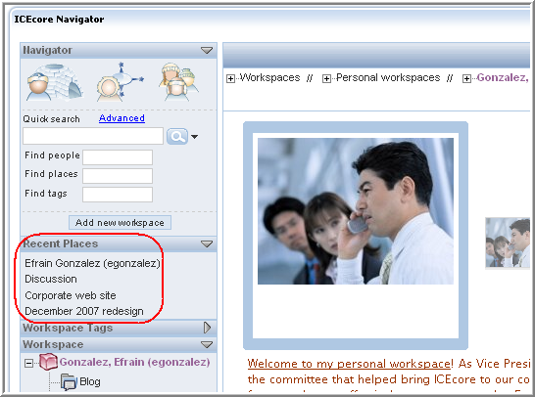
Notice that ICEcore now includes Efrain’s personal workspace in the list of recently visited places.

1.2.5 Returning to the Portal Page
To return to the portal page you saw when you first signed in, click the left-arrow icon on the workspace or folder page, as follows:
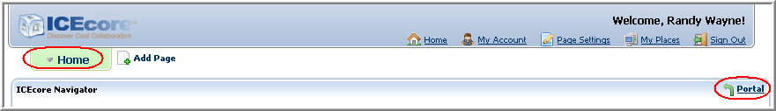

1.3 Using Help Mode
ICEcore has a fun and unique way of helping you to learn about product pages and tools. The portal page, and all workspace, folder, and entry pages, include a Help icon, which is shown in the picture on the following page.
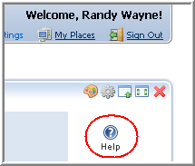
When you click this icon, ICEcore enters Help mode. ICEcore dims the page, displays the Help-mode control panel, and presents information icons ( i) next to each section of that page for which there exists Help information, as follows:
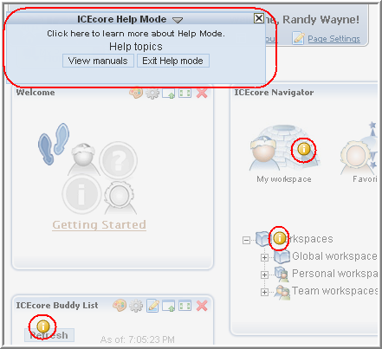
Click the information icon over the portion of the page about which you want more information. When you do, ICEcore displays a panel of information. When you are finished reading the panel, click the Close icon ( X) in the upper-right corner of the panel to close it. The picture on the following page shows a panel of Help information and its Close icon.
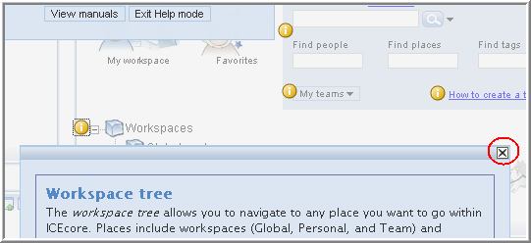
Some Help topics have more than one panel of information. To move to and from pages in a Help topic, you can use the linked panel numbers and arrows (which go to the previous or next panel) at the bottom of the page, as follows:
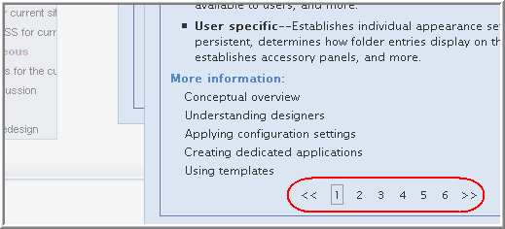
The Help topic in the previous picture has six pages. Either click the number of the page you want to view, or click the double-right arrow to move forward or the double-left arrow to move backward through the topic.
You might find that you want more room on the page to click information icons. If you choose, you can minimize the Help-mode control panel. To do so, click the Currently-displayed (down-arrow) icon, as follows:
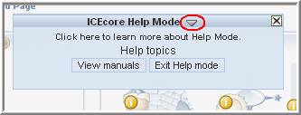
After you hide the contents of the control panel, it appears as follows:
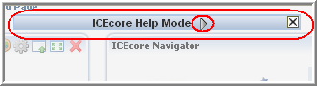
To display the contents of the control panel again, click the Currently-hidden (right-arrow) icon.
To view getting-started PDF manuals, click View manuals in the control panel. To exit Help mode, either click the Close icon ( X) in the control panel, or click any dimmed part of the page. The following picture shows the location of the View manuals button in the Help control panel:
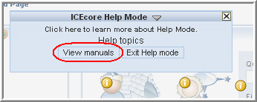

1.3.1 Help for Administrators
Site administrators and others might want to read overview information about administrative tasks. The administrative Help includes these topics:
- Administration-tools portlet -- Describes the tools available in the administration portlet. Administrators of the top workspace are allowed, by default, to perform workspace and folder administration anywhere in the installation, and they can use a subset of the administration-portlet tools (for example, create groups, and design entries and workflow processes). Site administrators can use all of the tools.
- Configuration -- Is the process of determining the content and appearance of workspace, folder, and entry pages.
- Access control -- Determines who has the right to perform which tasks in a given place.
- Workflow -- Allows you to create online representations of business processes (for example, document reviews, paid time-off requests, document approvals, and so on), which can then be applied to entries in folders.
If you would like to read more about these administrative topics, do the following:
- On the portal page, click Add Content, as shown on the following page.
- Click ICEcore:
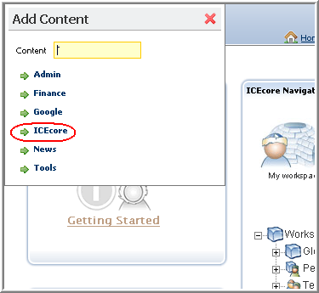
- Click Add next to the ICEcore Administration label:
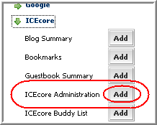
- Click the Close icon ( X), as shown on the following page.
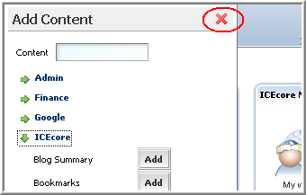
The ICEcore administration portlet appears on the portal page.
- Click the Help icon in the upper-right corner of the administration portlet.
- Links to the configuration, access-control, and workflow-overview topics appear at the bottom of the Help panel for the administration portlet, as shown on the following page.
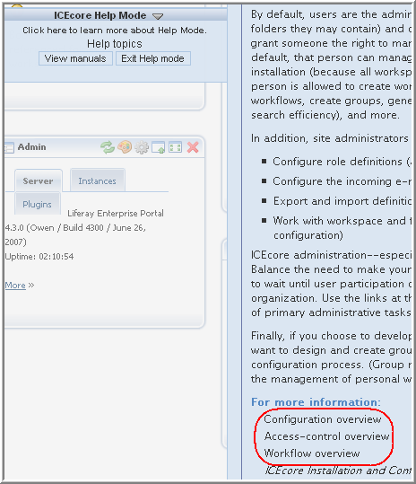

2.0 Getting Started
This chapter describes a few tasks that quickly demonstrate the basic features and concepts of ICEcore.
This chapter contains the following information:
- Section 2.1, Set Up Your Buddy List
- Section 2.2, Modify Your Personal Workspace
- Section 2.3, Create a Team Workspace
- Section 2.4, Use Advanced Search to Explore
- Section 2.5, Use the Workspace Tree to Explore

2.1 Set Up Your Buddy List
One of the most powerful tools in ICEcore is the presence icon. This icon tells you whether a person is online or not, and enables quick communication with that person (sending an instant message using ICEcore Conference, initiating an instant meeting using ICEcore Conference, sending e-mail, placing a call using Skype, and so on).
Although presence icons are displayed in ICEcore wherever you see someone’s name, a great way to get started with presence is to set up your buddy-list portlet, so that you see the online status of your buddies as you soon as you sign in.
To set up your buddy list:
- Sign in with your user name and password.
- Locate the ICEcore Buddy List portlet:
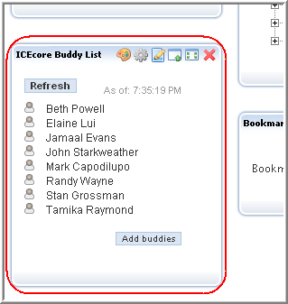
If you do not see the portlet, click Add Content in the upper-right corner of the portal page, click ICEcore, click the Add button next to “ICEcore Buddy List,” and click the Close icon ( X). ICEcore adds the buddy-list portlet to the portal page. If you require more assistance, see your ICEcore site administrator.
- In the portlet, click Add buddies.
ICEcore displays the “Configure buddy list” page.
- Begin typing the first few letters of either the first or last name of a buddy, and then click that person’s linked name in the drop-down list.
ICEcore includes the type-to-find feature. To use this feature, place your cursor in a text box that requires a known type of information, such as a name. Then, type a space, and then backspace over it. ICEcore then displays a list of links to all possible items:
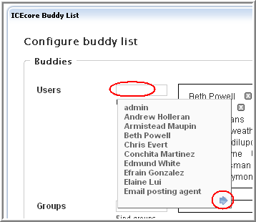
Notice the blue arrow in the bottom-right corner of the names panel. You can view next and previous panels of choices using the blue-arrow icons.
As you type characters in the text box, ICEcore adjusts the list to match what you type. The following example shows what happens in the example installation when someone types a few letters:
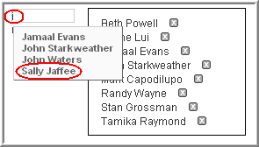
ICEcore displays a list of links of all the people whose first or last names match what you have typed so far. Click the linked name to add that person to your buddy list.
- Repeat Step 4 as often as necessary to add all of your buddies.
If you mistakenly add a name, click the Delete icon ( X) next to the name to remove it:
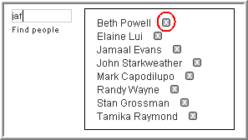
- Click Apply.
- Click Close.
To ensure that the buddy-list portlet is showing you the most up-to-date presence information for your buddies, click Refresh in the portlet.

Tips for using buddy lists
- Here are descriptions of the presence icons:
Online
Away (recently online)
Offline
Status unknown
- To communicate with a buddy, click the presence icon and select a communication method (instant message, instant meeting, e-mail, and so on).
- To view a buddy’s personal workspace (which includes contact information), click the linked name of your buddy.

2.2 Modify Your Personal Workspace
As the next step involved with learning to use ICEcore, it can be fun to create a comfortable working space in your personal workspace.
Your personal workspace is your ICEcore homepage. Like any workspace, such as your desk at work, or your wood shop or kitchen at home, it can be helpful to brighten, organize, or personalize your environment. It is also helpful to provide a safe space for people to visit you in your workspace (for example, a waiting or viewing area). You can apply similar approaches to your online workspace in ICEcore.
By default, other people are allowed to visit your workspace, but only you may participate in it. Participation means that you can create new entries in your folders, and visiting means that people can read your entries and can comment on them.
This section contains this information about enhancing your personal workspace:
- Section 2.2.1, Add Basic Information
- Section 2.2.2, Edit Contact Information and Add Pictures
- Section 2.2.3, Add a Blog Entry
- Section 2.2.4, Collaborate with Others

2.2.1 Add Basic Information
As the first step, it can be helpful to provide some introductory text for visitors to your personal workspace.
To modify your personal workspace, do the following:
- On the portal page, click My workspace in the navigator portlet:
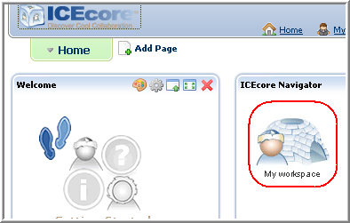
- Click Manage > Modify this workspace, as shown on the following page.
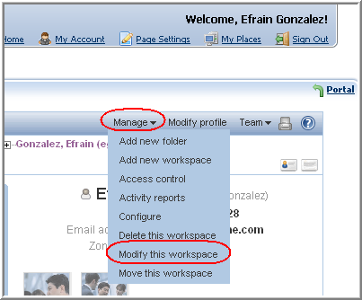
ICEcore displays a form that allows you to add a personal description to your workspace, as shown in the picture on the following page.
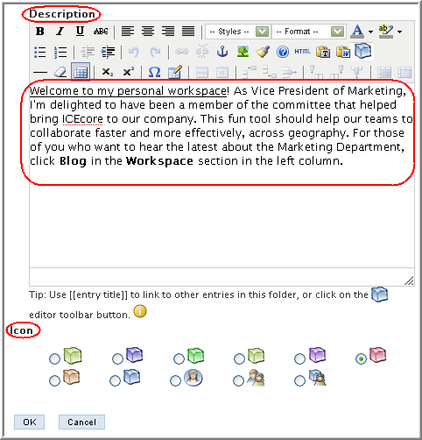
Consider using the editor in the Description section to compose a welcome message for people visiting your page. This is an HTML editor; you can use the tool bar at the top to format your message with bold text, color, pictures, tables, and so on. You can also use the Icon section to select a different icon for display in the workspace tree next to the link for your personal workspace.
- Click OK.
ICEcore displays the personal workspace page again, as shown on the following page.
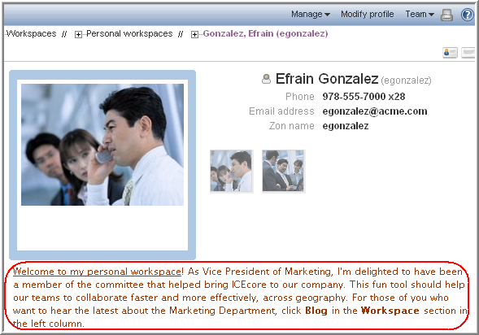
While viewing a personal workspace page, you can collapse the contact information so that it is easier to see more of the content. To collapse the contact information, click the Hide-contact-information icon in the upper-right corner of the workspace page, as follows:
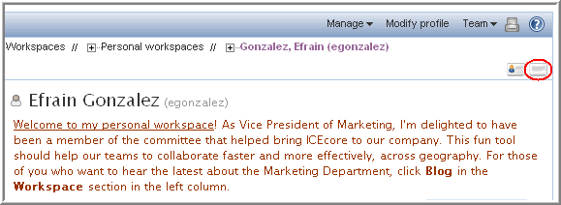
Click the Show-contact-information icon (to the left of the Hide icon) to display the contact information again.

2.2.2 Edit Contact Information and Add Pictures
Although your ICEcore site administrator probably specified some of your contact information, it is a good idea to check it, modify it, and make sure that it is complete. For example, the presence feature requires that your specify your ICEcore Conference user name correctly on your personal workspace.
Also, uploading pictures can help visitors to identify you, and it can provide decoration and amusement.
To modify your contact information and upload pictures:
- Click Modify profile:
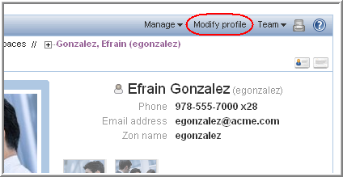
ICEcore displays a form that allows you to alter contact information and to upload pictures.
- Alter any contact information that is missing or incorrect.
- Click the Browse button to upload a picture:
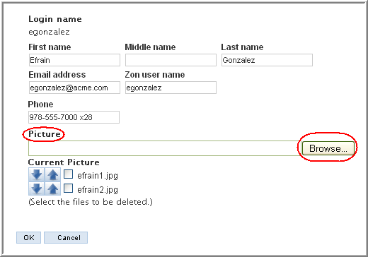
ICEcore places the filename of the picture in the “Current pictures” section of the page.
- Repeat Step 3 until you upload all the pictures you want into your personal workspace.
- Next to the filenames of uploaded pictures, click the up or down arrow to reposition the picture in the list (so as to place your best picture first):
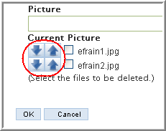
To delete a picture from your personal workspace, click the check box next to the filename, and ICEcore removes it after you submit the form.
- When finished, click OK to submit the form.
ICEcore displays the first picture in your list as the main picture in your personal workspace, and displays all other pictures as thumbnails (smaller versions) below the contact information:


Tips for uploading images
- You may add as many pictures as you like, but you must add them one by one.
- When viewing any personal workspace, move your cursor over the thumbnail pictures located just below the contact information, and ICEcore displays each picture in the larger frame to the left of the contact information.
- Click any of the pictures in the personal workspace, and ICEcore displays a full-size version of that picture.

2.2.3 Add a Blog Entry
Blogs are a new and popular communications tool available on the Internet. Blog folders display journal entries chronologically (starting with the most recent, and ending with the oldest). The blog folder in your personal workspace is for your journal entries.
From a teamwork perspective, a blog can present your newest ideas to your teammates in a fun, informal way. Comments that teammates make about your journal entry can help you to further develop your ideas. Blogs provide a way to collaborate informally before the work must become more structured.
To add an entry to your blog:
- View your personal workspace page.
- In the Workspace section of the tools sidebar, click the title of your blog folder ( Blog, by default):
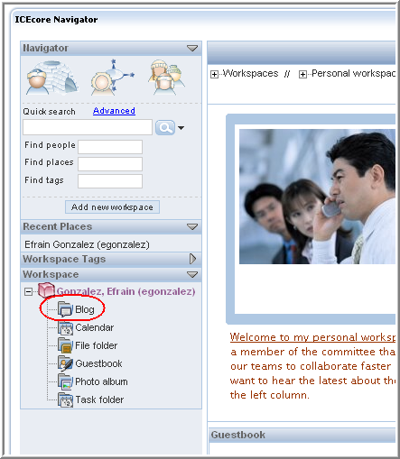
- Click New: Blog entry, as shown on the following page.
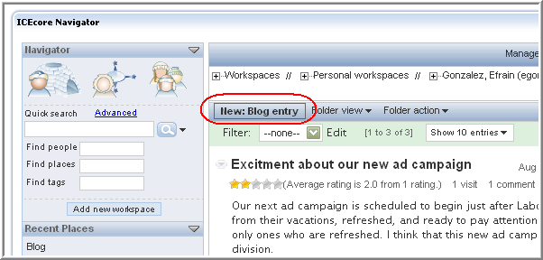
ICEcore displays a form.
- Provide a title, and type your journal entry in the Description section of the form.
- If you choose, you can click Browse to upload a picture or supporting document in the Attachments section of the form.
- Click OK.
This is an example of a blog entry as it appears on the folder page:
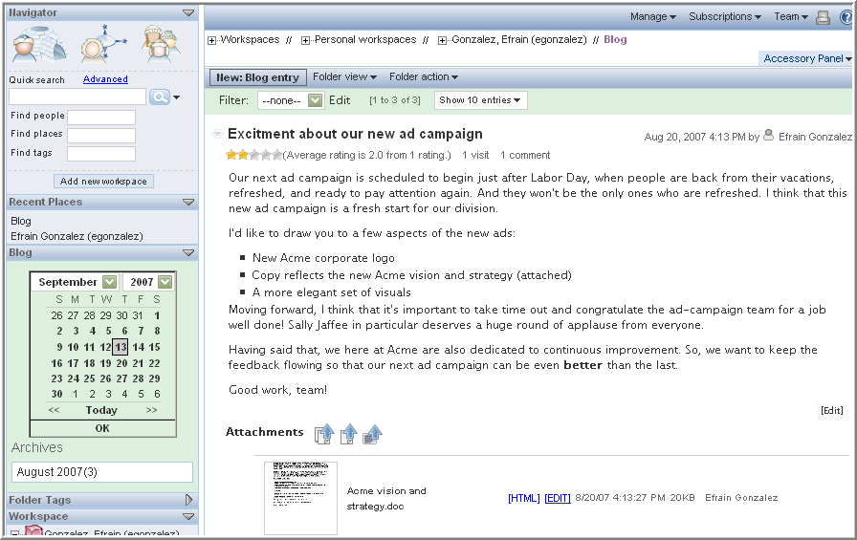
The picture on the following page shows the content of the entry.

Later, you can check the tools at the bottom of your blog entry for comments:
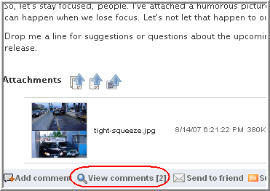
Click View comments to see them (and click again to hide them):
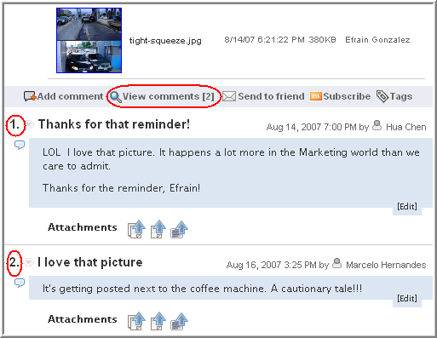

Tips for writing blog entries
- Attach pictures or supporting documents to make your journal entries more interesting.
- For pictures available on the Internet, you can use the HTML editor to place the picture right into your entry.
- Invite others to comment by asking for specific kinds of feedback.

2.2.4 Collaborate with Others
After doing the tasks described in the previous sections, you have completed the minimum number of tasks strongly recommended to get started using your personal workspace. Developing a vibrant, purposeful collaboration space requires striking a balance between having something for people to do when they first arrive in a space (read your introduction, view your pictures, note your contact information, and read and comment on your blog entries), and allowing the participation of your teammates to guide you in developing additional content.
This section provides ideas for further activity involving personal workspaces. Consider these points over time, as you become more accustomed to working with ICEcore.

Commenting on a Blog Entry
While you are waiting for teammates to comment on your initial blog entry, you can add a comment to someone else’s blog entry:
- Sign in and view the portal page.
- In the “Find people” text box, type a few letters of a teammate’s first or last name, and click the linked name of the person whose blog you want to view:
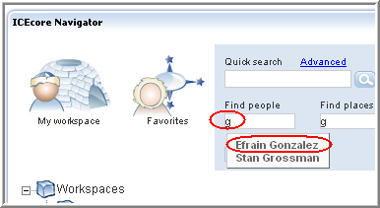
- In the Workspace section of the tools sidebar, click the title of the person’s blog ( Blog, by default), as shown on the following page.
- At the bottom of a blog entry, click the Add comment link, as shown on the following page.
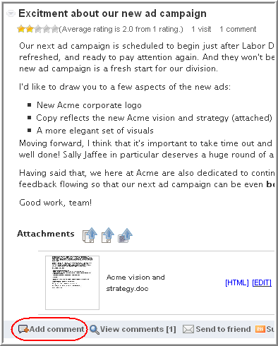
ICEcore displays a form just below the Add comment link.
- Provide text for your comment:
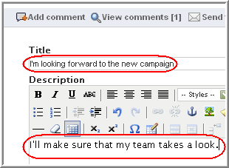
- Toward the bottom of the comment form, click OK.
ICEcore adds your comment to the blog entry:
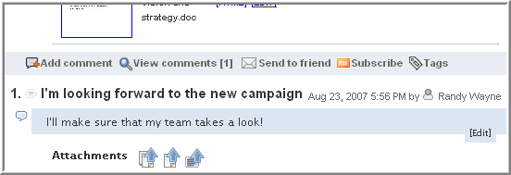

Collaborate in a Folder
The next section explains how to create a team workspace. Even though, by default, this process is very easy, you may want to use your personal workspace to learn ICEcore collaborative features before creating a team workspace. One way to do this is to create a folder and invite others to participate with you as teammates in the new folder.
To create a team-oriented folder in your personal workspace:
- View your personal workspace:
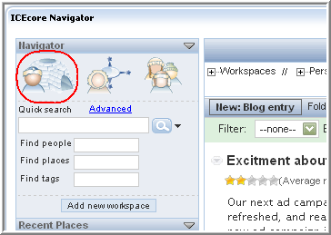
- Click Manage > Add new folder, as shown on the following page.
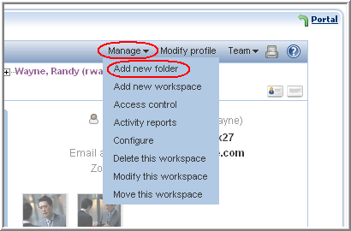
ICEcore displays a form that allows you to create a new folder.
- Provide a title for your folder and select a type of folder (our example uses “Discussion”).
- Click OK.
Your new folder appears in the Workspace section of the tools sidebar:
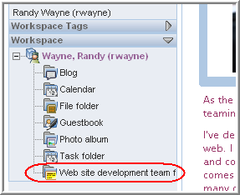
- Click the link for your newly created folder.
- Add new entries (optional).
- In the management-menu bar, click Team > Add or delete team members, as shown on the following page.
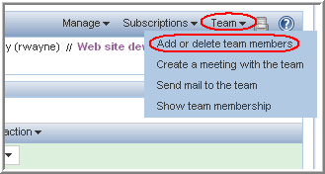
ICEcore displays a form telling you that the folder is not inheriting team settings and provides you with tools for specifying your teammates. Inheritance is helpful, because it makes many product features work automatically; if you wanted this folder for private use, then applying inheritance would be wise. In this example, however, you want to specify your teammates.
- Type a few letters of either the first or last names of teammates, and click their linked names (repeat as needed until you include all your teammates):
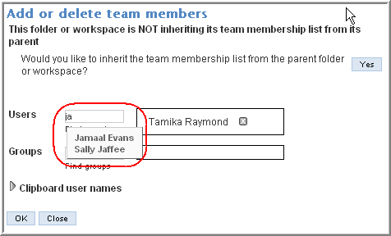
- Click OK.
ICEcore now allows teammates to participate in your newly created folder, instead of just being able to visit, as they do in other folders in your personal workspace. This means that teammates may take a more active role in the development of information in the folder. Following our example, when Randy Wayne returns to the “Web site development team folder” in his personal workspace, a teammate may have authored an entry, as shown on the following page.
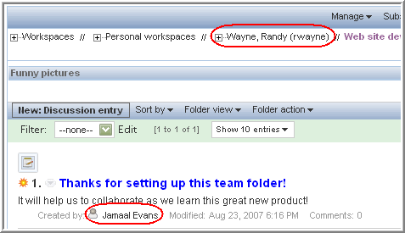
You can use team-oriented folders in your personal workspace until you feel more comfortable with the product features. Then, you can create a team workspace.

2.3 Create a Team Workspace
By default, anyone can create a team workspace (your site administrator will inform you, if the defaults are altered for your organization’s installation). Create a team workspace when a collection of workspaces and folders would facilitate your team’s mission.
This section includes:
- Section 2.3.1, Create the Workspace
- Section 2.3.2, View Team Members
- Section 2.3.3, Communicate with Teammates
- Section 2.3.4, Allow Visitors to Your Team Workspace

2.3.1 Create the Workspace
- From the portal page, in the workspace tree, click Team workspaces:
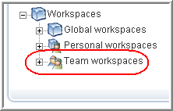
By default, all team workspaces are contained within “Team workspaces.” Your site administrator may instruct you to go to a different workspace to create your team workspace. If so, the remaining steps in the process are the same.
- Click the Add a team workspace button:
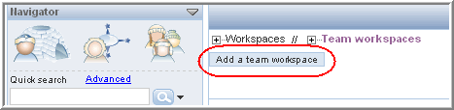
ICEcore displays a form used to create your team workspace.
- Provide a title for your team workspace.
- In the “Team members” section, use the type-to-find feature (typing a few letters as ICEcore supplies a list of links that match what you have typed so far) to specify your teammates.
- In the “Workspace folders” section, click the check box next to the folders you want your team workspace to contain. (You can also add subworkspaces and more folders later.)
- If you choose, you can provide an announcement to be sent by e-mail to your team members, so that they know about the new team workspace.
- Click OK.

Tips for Team Workspaces
- As the owner of this workspace, you are primarily responsible for workspace administration. Examples of those tasks include creating other containers for information (subworkspaces and folders), possibly adjusting access control (which determines who may do what in the workspace), and providing some initial content to assist team members with getting started.
- Do not provide a large volume of content. For the workspace to match the needs and style of your team, your teammates active participation should contribute content and guide administrative decisions.

2.3.2 View Team Members
By default, ICEcore includes a team-membership accessory on your workspace page, which shows you your teammates. Accessories are sections at the top of workspaces and folders that provide summary information for you. In this case, the accessory shows you a list of team members for the new team workspace. If you want to close an accessory to provide more room for viewing other contents of the workspace or folder, click the Currently-displayed (down-arrow) icon toward the upper-right corner of the “Team members” accessory panel, as shown on the following page.
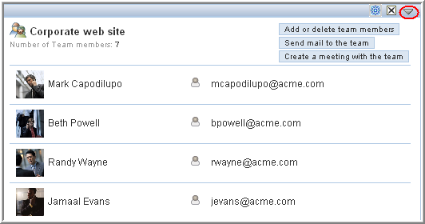
If this accessory is not present, do the following to view the team membership:
- View your team workspace.
- Click Team > Show team membership.

2.3.3 Communicate with Teammates
In addition to having a workspace to contain more items, team workspaces allow for faster communication among teammates. To use team communication tools:
- Click the Team menu on the management-menu bar.
- Click either Create a meeting with the team or Send mail to the team.
Teammates participate in meetings using their ICEcore Conference clients.

2.3.4 Allow Visitors to Your Team Workspace
By default, only team members may view and participate in the workspaces and folders contained in the team workspace. There may be times when you want to allow other people to visit your team workspace (which, by default, means that they can read entries and comment on them, but they cannot create entries).
To allow visitors to your team workspace:
- Sign in as the owner of the team workspace.
- Navigate to your team-workspace page.
- Click Manage > Access control, as shown on the following page.
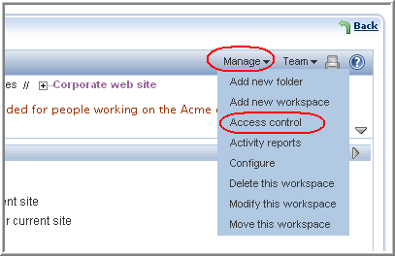
ICEcore displays the “Configure access control” page for the team workspace.
- In the “This folder inherits...” section, if it is not set to No already, click the no radio button, and click Apply:
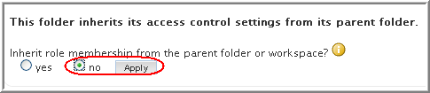
- Click Add a role > Visitor:
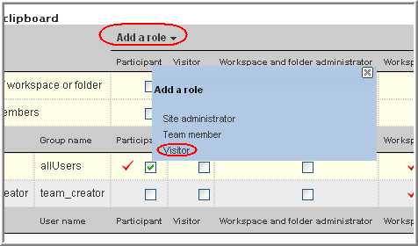
- Click Add a user, and use the type-to-find feature to select a name, as shown on the following page.
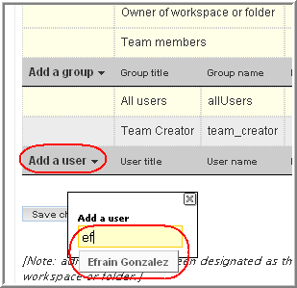
- In that new user’s row, click the check box in the Visitor column:
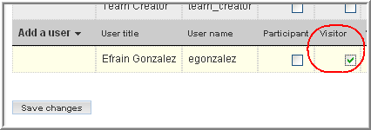
- Repeat Steps 6 and 7 until you have added all your visitors.
- Click Save changes.
- Click Close.
Now those people have the right to view your team workspace and to add comments to existing entries. They cannot create new entries.

2.4 Use Advanced Search to Explore
When you perform a quick search, ICEcore searches all workspaces and folders. Use the Advanced search feature to perform more complex or finely tuned searches. Here is an example of using Advanced search to restrict the scope of the search to two folders:
- From either the navigator portlet or the Navigator section of the tools sidebar, in the search section, click Advanced, as shown on the following page.
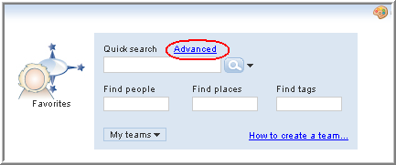
- Type text that an item must contain, and check the box of one or more workspaces or folders in which to restrict the search:
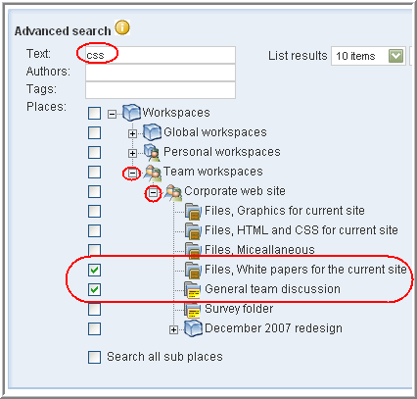
- Click Search.
This advanced search returns links to only those items in the “Files, white papers...” and “General team discussion” folders that contain the string “css”. Summaries of items that match the search criteria appear just below the section shown in the previous picture.

2.5 Use the Workspace Tree to Explore
In addition to using search to explore workspaces and folders in ICEcore, you can open any workspace tree, and you can visit all the places in which you are allowed to visit or participate. For example, your site administrator can use the “Global workspaces” container to create workspaces and folders for broader use throughout your organization.
The following picture shows a possible set of workspaces and folders located in the Global workspace:
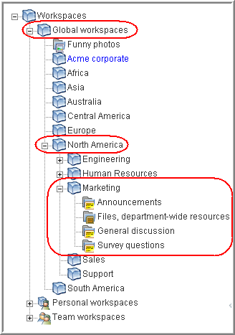

3.0 Features Overview
This chapter provides a brief overview of most of the ICEcore tools, folder types (or “applications”), and workspaces.

3.1 Tools
This section describes various tools that enhance navigation, usability, knowledge management, and other aspects of ICEcore.

3.1.1 Accessories
Accessories are subsections of a workspace or folder page that enhance the use of ICEcore pages in various ways. Accessories do not contain new information; instead, they point to existing information, organizing and presenting it in a summarized way that can be helpful to you. This section presents two examples of accessories to help you understand how you can use them.
To create an accessory, click Accessory Panel > Add an accessory:
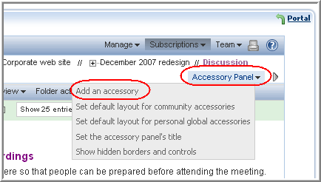
In addition to the various types of accessories (photo gallery, search results, blog, and so on), there are categories that determine the scope of the accessory, as follows:
- Personal accessory for this page only: This accessory appears only to you and only on the currently displayed workspace or folder page.
- Personal accessory for all workspaces and folders: This accessory appears only to you, but it appears on all workspace and folder pages that you view.
- Community accessory for this page: This accessory appears only on this page, and it appears to everyone who views the current page. Only workspace and folder owners are allowed to establish community accessories.
For folders, accessories appear above the folder content, as shown on the following page.
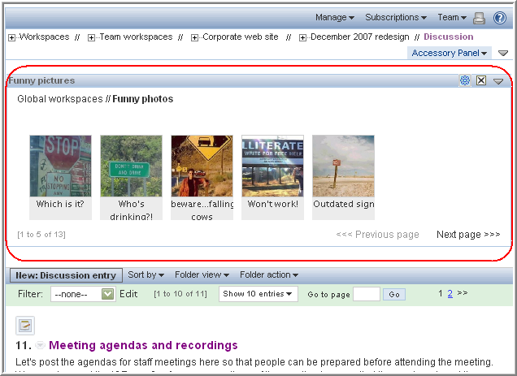
To close an accessory or the entire accessories panel, click the appropriate Currently-displayed (down-arrow) icon:
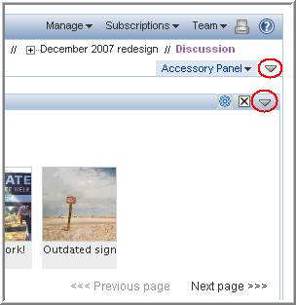
To move an accessory, reordering it within the accessories currently located in the accessory panel, click on its title bar, drag it to your desired position within the accessories panel, and drop it.
To delete an accessory, click the Delete icon ( X). Remember that accessories do not contain information; they merely point to and summarize information that exists elsewhere. So, when you delete an accessory, you delete the pointer, not the source information. Also, it is very easy to add the accessory again, if you mistakenly deleted it.

Adding an Accessory Visible on All Pages
Using our example installation, the company provides a photo gallery of amusing pictures in the Global workspace area, and one of the characters in the installation wants to have access to these pictures to amuse himself, no matter where he is within ICEcore. So, the user creates this accessory as a “personal accessory for all workspaces and folders.”
Now, notice that the photo-gallery accessory appears when he views the file folder containing graphics for his web-site-redesign work:
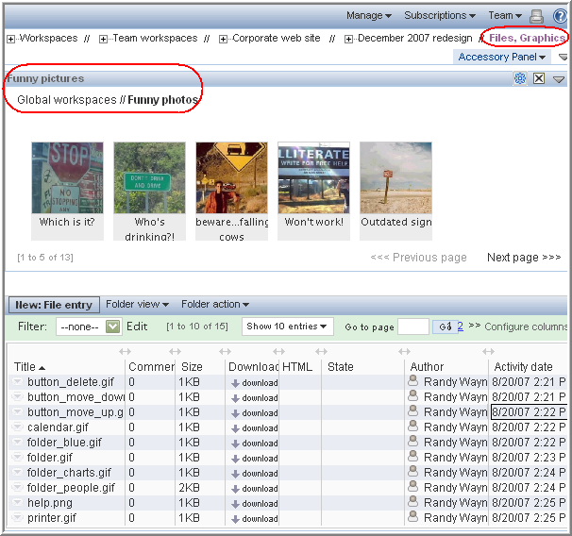
And it appears when he views the discussion folder for the web-site redesign effort, as shown on the following page.
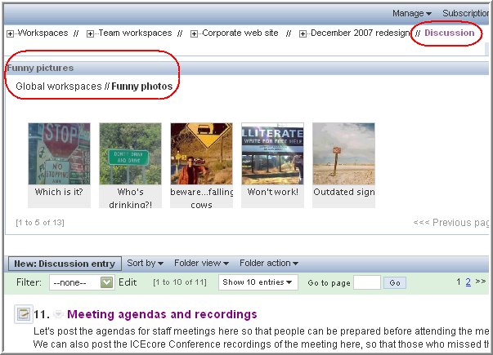
To be able to save room for viewing the content of the folder, the person can close either just the photo-gallery accessory or the entire accessory panel itself. This close setting is “sticky”; it remains in effect for every page that this person views:
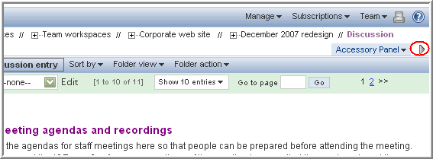

Adding an Accessory for One Page
Suppose that the character in our sample installation wants to be able to review quickly all of the entries in a discussion folder that he authored. He can create a Search-results accessory applicable to only that Discussion folder, as shown on the following page.
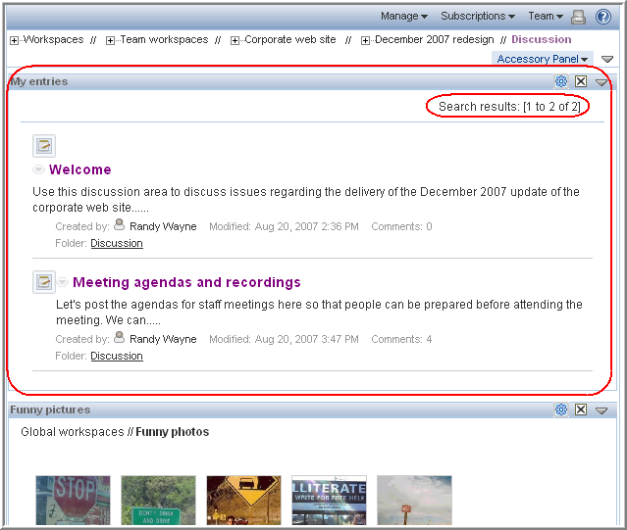
This person can close the search-results accessory (or the entire accessories panel) to be able to see the folder contents displayed closer to the top of the page. Finally, suppose that this person wants to fine tune his search criteria further. To reconfigure an accessory, click the Configure icon:
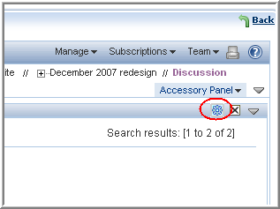

Layout
When you create accessories for every page that you view or for a community-accessories panel, ICEcore provides a tool for arranging the order of the accessories within the panel. In this way, you can determine an optimal default order in which the defined accessories appear within the panel. (People may personalize the order by dragging and dropping accessories within a community panel.)
To affect the layout of a personal-global or a community accessory panel, use one of the following tools:
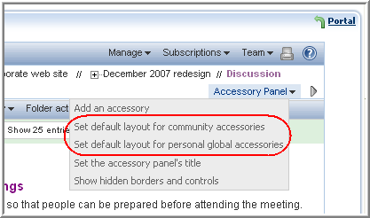
ICEcore then displays the accessories in the reverse order in which they were created. Click the title bar of an accessory, drag it, and drop it into the position you wish it to have. Repeat this action until the accessories are ordered to your liking, and then close the form.

3.1.2 Favorites
The favorites panel allows you to save links to your favorite pages. Because almost all ICEcore pages display the navigator tools (including the Favorites icon), you can access your favorite pages from almost anywhere.
The following picture shows that you can either add the current page to the favorites list or you can click on a Favorites link to view that favorite page:
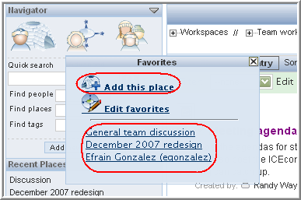

3.1.3 Tags
Tags provide an alternative way to categorize items, making it easier to navigate to and search for them later. Given our sample installation, there is a file folder that contains all of the graphics used in a web-site redesign. It might be helpful to tag the folder as containing “artwork” and “icons.”
After viewing the file folder, click the Currently-hidden (right arrow) icon, click Tags, enter the personal tag name, and click Add, as shown on the following page.
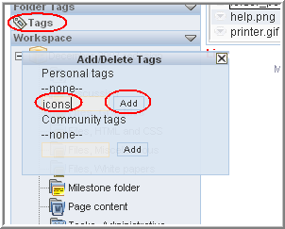
When you are finished adding all the tags you want, click the Close icon ( X).
The Tags section of the tools sidebar now appears as follows:
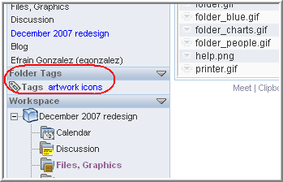
Both of the tag names ( artwork and icons) are links. Click a tag name, and ICEcore searches for all items that have that tag applied to them. Also, in the “Search tags” text box, you can now search for these tags:
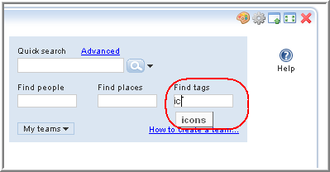
To remove a tag from an item, view the item, click the Tags link and icon, and click the Delete icon ( X) next to the tag name. If you are a workspace or folder owner, you can create community tags, which other people can use to search for items.

3.1.4 Filters
Filters allow you to see only the subset of folder entries that most interest you. To create a filter, view a folder, and click the Edit link next to the Filter drop-down list:
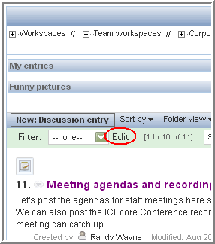
Using our sample installation, the person can create a filter that displays all of the web-site-redesign discussion entries that contain the word “navigation”:
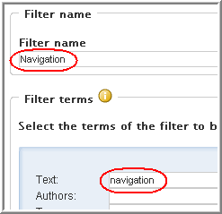
In the Filter drop-down list, you see only the filters that you create. When you select a filter, ICEcore displays only those entries that match that filter’s search criteria, as shown on the following page.
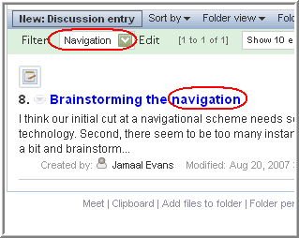

3.1.5 E-mail Notifications
Using ICEcore, there are several ways to monitor activity in a folder. For example, you can see a count of unread entries in the bookmarks portlet, and you can set up an RSS feed. The most popular way of tracking activity in a folder is to receive e-mail notifications.
When you establish e-mail notifications, ICEcore sends an e-mail message to you, on a schedule determined by owner of the folder, which summarizes the changes to the entries and provides you with links to those entries. When you establish e-mail notification for a folder, the messages automatically include summaries of changes to all of its subfolders.
After viewing a folder for which you want to receive notifications, click Subscriptions > Email notification:
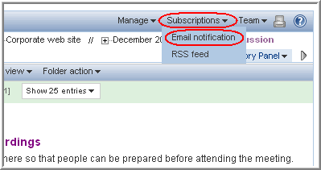
ICEcore dims the page and offers you several styles of e-mail notification:
- Digest -- ICEcore sends one message that summarizes all of the activity in the folder and its subfolders.
- Individual messages -- ICEcore sends one message for every new or changed entry in the folder and its subfolders. The e-mail messages do not include files that may be attached to the new or changed entries.
- Individual messages with attachments -- This style is the same as the last, except that messages include attached files.

3.1.6 The Clipboard
The clipboard is a tool that allows you to gather people’s names as you visit places (workspaces and folders) within ICEcore. Later, when using a tool that requires people’s names, you can retrieve names from the clipboard.
Using our sample installation, a person can visit the discussion folder within a team workspace, scroll to the bottom of the folder page, and click Clipboard:
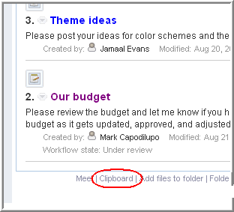
ICEcore then displays the Clipboard panel. You can use buttons on this panel either to add the names of everyone who authored an entry or comment on the currently displayed page, or you can use them to add the names of all team members associated with the currently displayed page.
After adding and editing names, the clipboard can look like this:
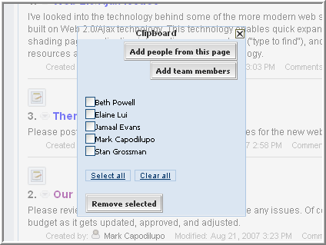
When you check the box next to names and click the Remove selected button, ICEcore removes the checked names from the list and closes the clipboard panel. To close the panel otherwise, click the Close icon ( X) in the upper-right corner of the panel.
As the next step, this person can visit any number of places, adding additional names to the clipboard as desired.
Finally, before signing out, this person can use the names he has collected from potentially many different places within ICEcore and apply them to a task. The following picture shows how you can retrieve Clipboard names using the “Send mail” ICEcore tool:
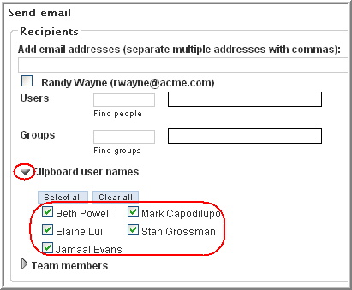

3.1.7 Entry-Reference Mark-Up
When creating or modifying an entry, you can create a link to any other entry within ICEcore. The easiest way to create this link is to use a tool in the HTML editor. Given our sample installation, in the wiki folder for the website-redesign project, you can reference other wiki pages. You can highlight text in the body of the entry, and then click the mark-up icon in the HTML editor tool bar, as follows:
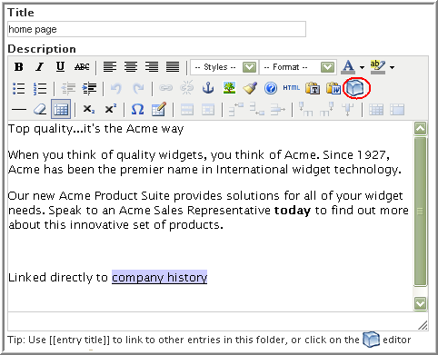
ICEcore displays a new window. Click the Find link, and use type-to-find to specify the title of an entry:
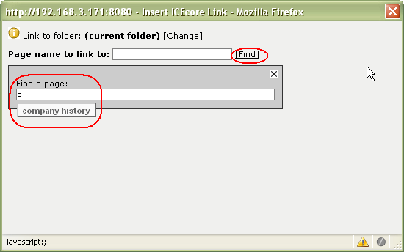
Select the correct entry title, and click the Insert link. ICEcore inserts the link into the body of your entry.
This entry-reference mark-up tool also allows you to look for entry titles in other folders. To do so, click the Change link.
Finally, if you want to hand-code the reference to another entry in the same folder, you can enclose the exact title of the entry within double brackets, as follows:

Linked directly to [[company history]]
Although you can use entry-reference mark-up in any folder, it is used heavily in wiki folders.

3.1.8 Rating Stars
ICEcore provides a rating system that allows you to see how other people have evaluated the content of an entry on a scale of one star (not very impressive or relevant) to five stars (incredibly impressive or relevant).
To evaluate an entry, click the star that represents your evaluation. For example, to give an entry a rating of three stars, click the third star (left to right).
ICEcore indicates the average rating and the number of people who have rated the entry so far. Consider this picture:
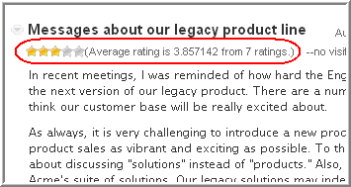

3.1.9 Workflow
A workflow process is an online version of a business process (for example, ordering supplies, hiring new employees, requesting paid time off, and getting expense reimbursements). By creating custom forms and applying workflow processes, your ICEcore site administrator can use ICEcore folders as application platforms. Consult with your site administrators to see if you have common business practices that can be automated using your ICEcore installation.
As a folder entry moves through a business process, it enters states that provide a brief status for the entry. For example, a paid-time-off workflow process can have states such as Submitted, Approved, Denied, and Being Processed by Human Resources.
When you are viewing an entry that is progressing through a workflow process, and if you have permission, you can change its state using a drop-down list and an OK button, as shown on the following page.
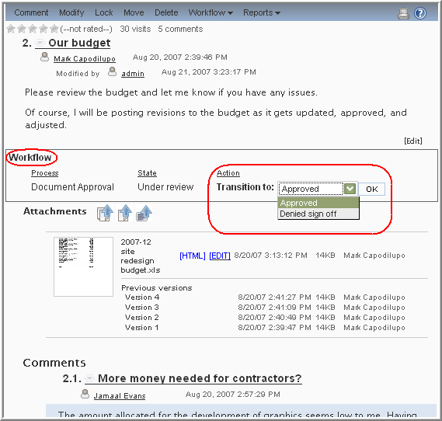

3.1.10 ICEcore Conference
ICEcore Conference is a real-time collaboration tool that allows you to send instant messages, schedule online meetings, and have instant online meetings with people participating in your ICEcore installation.
The features of ICEcore Conference are described in a separate set of documentation. However, the synchronous features (ICEcore Conference) and asynchronous features of ICEcore are integrated in helpful ways. As mentioned, ICEcore provides you with a Buddy List portlet. Also, anywhere you see a person’s name in ICEcore, you see that person’s presence indicator. Finally, at the bottom of a workspace and folder pages, you can quickly start an instant meeting with all teammates for that particular page, or with all people who have authored entries and comments on the current page.
You are presented with contact options when you click on someone’s presence icon, as shown on the following page.
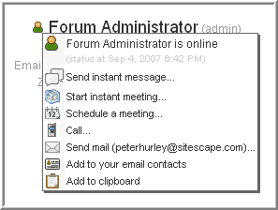

3.1.11 Accessibility Mode
ICEcore provides a mode of operation that is optimized for use with assistive devices (for example, web-page readers that assist blind users). Accessibility mode complies with U.S. Section 508 and W3C international standards of accessibility.
To use ICEcore in accessibility mode, view your personal workspace, and, at the bottom of the page, click Enable accessible mode:
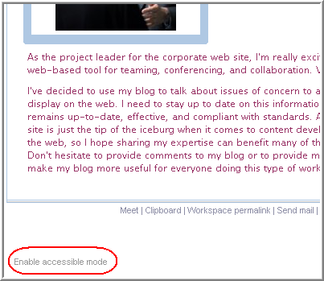

3.2 Folder Types
This section describes the various ICEcore folder types. Folder types define the type of activities that you do within a folder and how you do them. So, folder types can actually be thought of as applications, where each different type of folder functions as a separate “program” within ICEcore.
Most of the folder tools are common across all types of folders. Examples include most of the tools in the tools sidebar, accessories, subscriptions, team features, sorting, folder views, filtering, and basic folder-page navigation. The subsections that follow are ordered alphabetically and indicate some significant differences in the way a particular folder type functions.

3.2.1 Blogs
Blogs are chronologically listed journal entries. Blog entries resemble discussion-list entries:
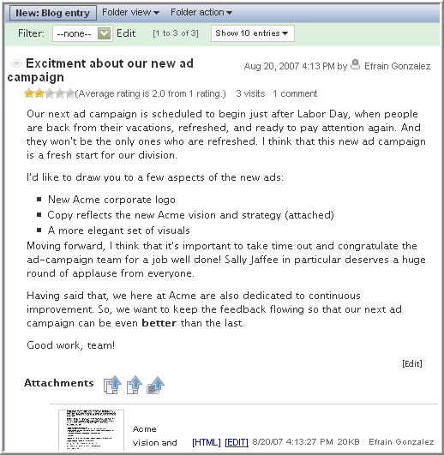
The tools sidebar also includes a calendar (click on a date to see that day’s blog entries) and an Archives section (click on the linked name of a month to see that month’s blog entries), as shown on the following page.
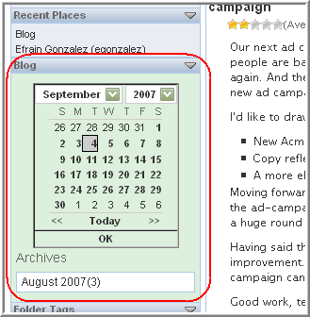

3.2.2 Discussions
Discussion folders allow you to post entries and make comments about those entries. This manual has described discussion folders, and shown pictures of their tools and pages.
By default, if you choose, there are two views that are designed for use with discussion folders. A view is a page design used to display information (in this case, information about entries and comments in a discussion folder). For example, if you changed the view from its default (“list”) to “table,” then a discussion folder appears as follows:
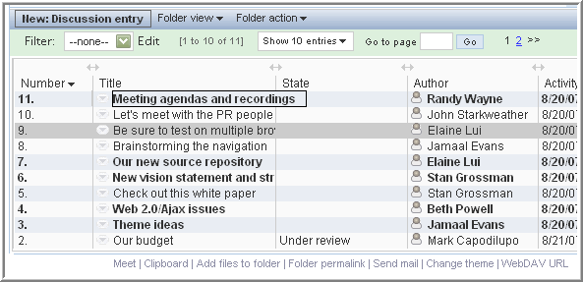
Titles of entries that have not yet been viewed are bold. Hover your mouse over a title, and ICEcore displays the full text of that title. Click, hold, and drag one of the double-arrow icons that are located above the horizontal lines in the table, and you can expand and collapse the column. Click on a column header ( Number, Title, State, Author, Activity date), and ICEcore sorts the table by the values in that column.

3.2.3 Calendars
Calendars help you to keep track of time-ordered appointments or events. By default, a calendar folder displays a monthly view of events:
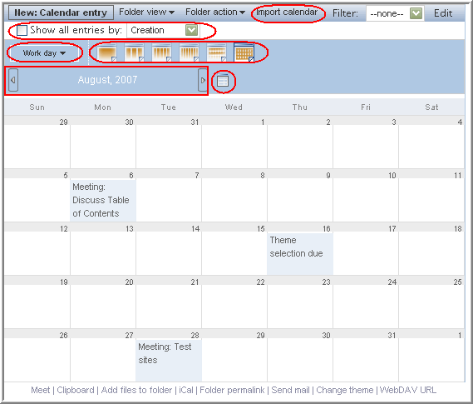
Here are some of the unique calendar tools:
- Import calendar: Allows you to import calendar entries in iCal format (for example, entries from Google and Outlook).
- Show entries by: Changes the criteria used to place the event on the calendar from the default, which is the event date. (This feature is most useful when viewing non-calendar information in a calendar view. For example, by default, you can view discussion entries in a calendar view, and then you can use this feature to show entries according to creation or “last activity” date.)
- Work day: Allows you to define a day as being a work day (defined by your site administrator) or as a full calendar day (which includes non-work days, such as weekend days).
- Number of days: Changes the number of days shown on a calendar folder page (the default is one month, thirty days).
- Previous and next page: Displays the previous set and next set of days. For example, if the calendar is currently displaying a month, these icons display the previous and next month of entries.
- Calendar applet: The square icon to the right of the next-page icon displays a panel displaying the current month, which you can use to navigate to specific months or days.

3.2.4 Guestbooks
Guestbooks are folders that allow visitors to sign in and announce their presence on a page. By default, personal workspaces contain guestbooks and accessories that show a summary of the guestbook entries. Given our sample installation, the guestbook on the following page is in one person’s personal workspace.
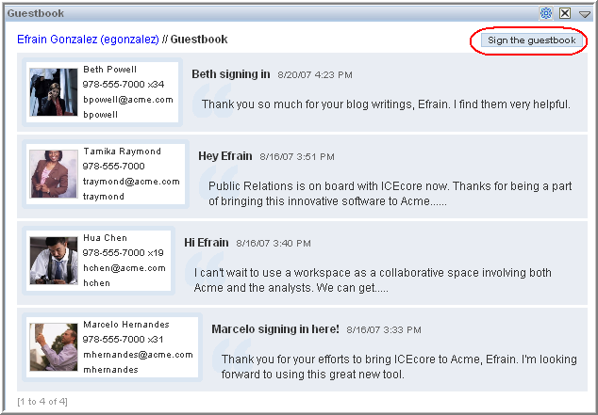

3.2.5 File Folders
File folders contain an alphabetized list of files in a table format. The table functions the same as the table view described in the discussion-folders section. Consider the following:
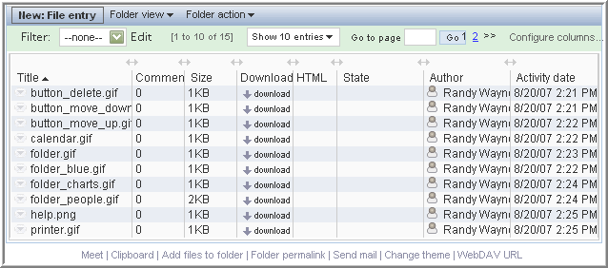

3.2.6 Milestone folders
A milestone folder tracks the progress of several task folders. Although you can use milestone folders outside of the scope of a project workspace, they are most often used in those workspaces. See the project workspace section for more information.

3.2.7 Photo Albums
Photo albums display pictures. Our sample installation includes a set of humorous pictures placed in a photo album in the Global workspace area, as follows:
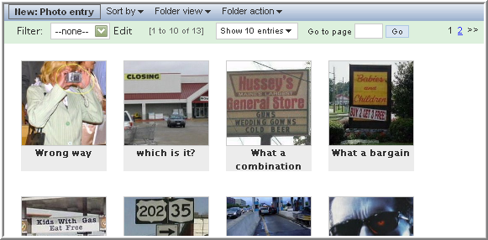
When you click on a thumbnail, ICEcore displays the full-sized photo in a separate window, as shown on the following page.
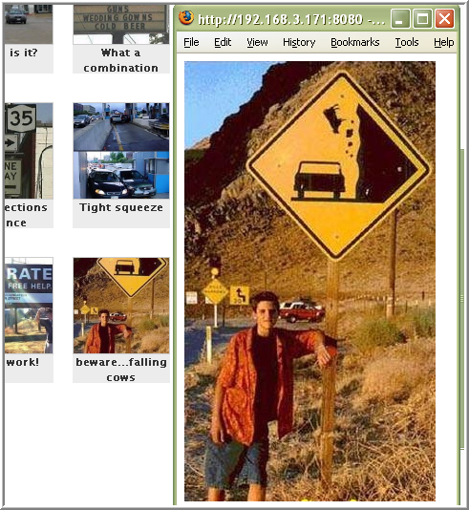

3.2.8 Surveys
Surveys allow you to conduct polls. You can create polls that allow a single answer to a question or that allow multiple answers to a single question.

3.2.9 Tasks
A task folder keeps track of the progress made in completing work assignments. Although you can use task folders outside of the scope of a project workspace, they are most often used in those workspaces. See the project workspace section for more information.

3.2.10 Wikis
Wikis are folders whose entries are coauthored by all participants in the folder. Wiki folders have additional tools in the tools sidebar, as shown on the following page.
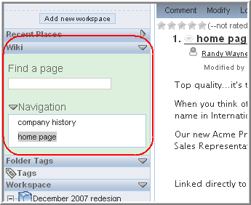
Use the type-to-find feature in the “Find a page” text box. The Navigation section lists all of the pages in the wiki folder. The standard folder tool “Show xx entries” determines how many page titles are listed here by default. If there are more pages, then ICEcore displays a right-arrow icon in the bottom-right corner of the Navigation box that allows you to move through lists of all the pages in the wiki folder.
By default, ICEcore does not display an entry when you first view a wiki folder. If you want an entry to display when someone first views the folder, click the Set main page link:
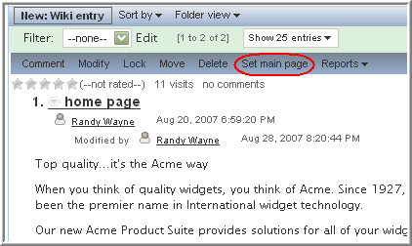
Note: When you create a wiki folder, be sure to configure the folder so that all entry titles must be unique.
When working with a wiki entry, it can be helpful to review edits that your teammates may have made to it. To review edits, view a wiki page, and click Reports > Edit history, as shown on the following page.
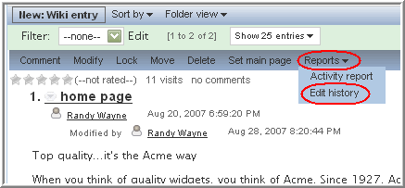
ICEcore displays a new browser window. In that window, select the edit versions that you want to review, and click Compare:
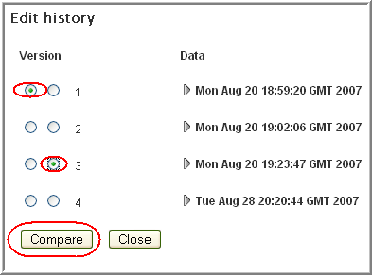
ICEcore displays a version of the entry that indicates additions and deletions between the two versions, as shown on the following page.
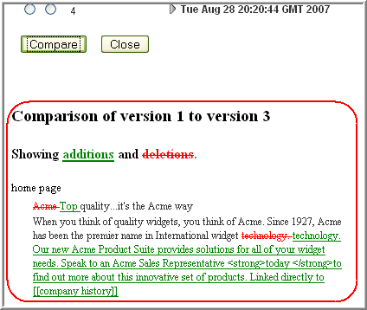

3.3 Workspaces
This section describes different types of workspaces available in ICEcore.

3.3.1 Global Workspaces
Global workspaces contain information beyond the scope of teamwork that may be of interest broadly across your organization. Given our sample installation, the example on the following page shows how the Global workspaces can be structured for the fictional Acme company.
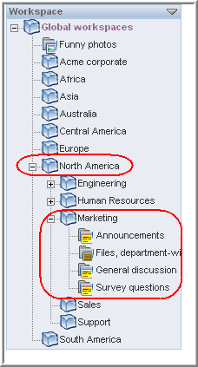
This particular example uses geography to organize the Acme company’s global information, and then uses departmental categories (Engineering, Human Resources, Marketing) to further organize the information. Depending on your organization, you may want to reverse the order (function followed by geography) or use some other organizational scheme.
Note: We strongly recommend that you limit the creation of Global workspaces. First, organic team creation is the more effective use model for this product. Second, we have worked with a significant number of customers who duplicated complex organizational charts in the structure of Global workspaces, and users found them to be confusing and unusable. Instead, populate the Global area with a minimal amount of information, and let users guide you as to a useful structure and content in this area.

3.3.2 Personal Workspaces
Personal workspaces provide a home page or start page for your work in ICEcore. It includes contact information, a guestbook, pictures of you, your personal blog, and more.
Previous chapters in this book describe personal workspaces.

3.3.3 Team Workspaces
Team workspaces provide dedicated workspaces for a small group of people to coordinate their efforts and to collaborate.
Previous chapters in this book describe team workspaces.

3.3.4 Project Workspaces
Project workspaces include special accessories that help a leader to track the progress of task completion for a potentially large project. Although project workspaces can contain any type of folder, they are specifically designed to work in conjunction with task and milestone folders.
In our sample installation, there is a corporate web-site development team. This team has begun a project that requires them to redesign the web site for a December 2007 deadline. So, the team created a team workspace for general web-site teamwork, and, within that space, it created a project workspace for the web-site redesign:
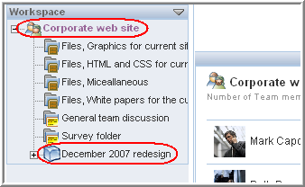
Within the project workspace, the project leader created standard folders (a discussion area and file folders for various types of files used in the project), a wiki folder to create web-site-page content, and three task folders for several categories of tasks involved in this project effort:
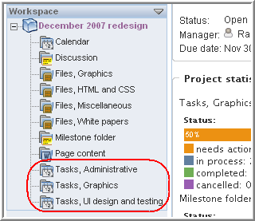
Each task folder contains tasks that fit that task category. An example of one of the task folders is shown on the following page.
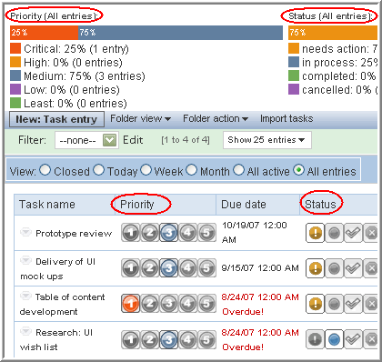
This is the “Tasks, UI design and testing” tasks folder. ICEcore produces the Priority and Status summaries using the individual task-data provided in the table toward the bottom of the folder. So, in the Priority summary, 25% of the individual tasks are marked Critical, and 75% are marked Medium. If the assigned person or the project leader changes the priority value of an individual task, ICEcore recalculates the summary located at the top of the folder. Finally, ICEcore displays radio-button filters at the top of the individual task listing that allows you to see only closed or active tasks, or only tasks due today, this week, and so on.
A designated individual can change the priority, status, or % done value for a task right on the folder page. For example, if you hover the mouse over the bar in the % Done column, ICEcore displays a percentage value that corresponds to the location of the mouse. When the appropriate percentage is displayed, click the mouse, and ICEcore adjusts the % done value, as follows:
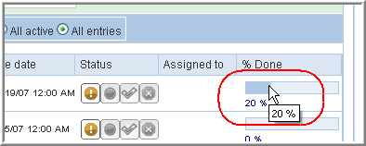
So, individual task status in one task folder is rolled up into the summary for that folder. The status values for each task folder roll up again into the milestone folder, as shown on the following page.
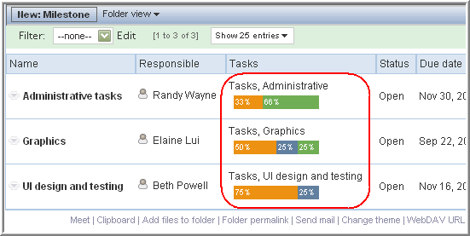
The milestones folder provides a snapshot of the status of each of the three task folders in our sample installation. Hover your mouse over the colors in the bar chart, and ICEcore explains the value (needs action, in progress, completed).
Finally, the information rolls up one more time, into the project-workspace page:
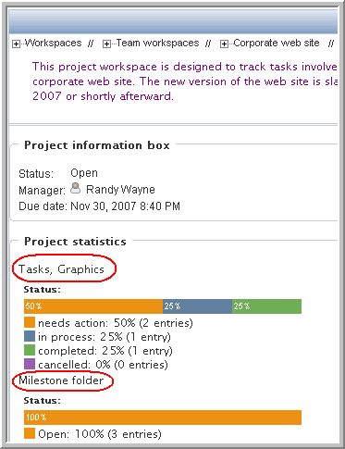

A.0 Troubleshooting
This appendix provides guidance for difficulties you might encounter when using ICEcore.

A.1 WebDAV Link Does Not Work
Problem: When clicking the Use this folder as a WebDAV folder link in the footer tool bar or the icon used to attach a file using WebDAV, the WebDAV window does not function properly.
When using Windows XP and Internet Explorer Version 7.0 or higher, ICEcore activates the WebDAV link in the footer and the WebDAV icon used to attach files. If the administrator of the folder you are currently using did not configure it properly for use with WebDAV, then the WebDAV window does not function properly. In order for a folder to enable WebDAV properly, it must be configured so that the names of all uploaded files are unique. To affect this setting, the administrator can click Manage > Modify this folder.

A.2 Too Many Sign Ins for WebDAV
Problem: When using WebDAV, you have to specify your ICEcore user name and password more than once.
This is proper behavior for WebDAV. WebDAV requires that you sign in each time you access a distinct program (for example, your web browser and ICEcore). It then may ask you to sign in again to access a file.

A.3 Not Understanding Mirrored Folders
Problem: You are not sure if you want to use mirrored folders, because you do not understand the concept or how they work.
Note: Mirrored folders are available only with the purchase of ICEcore Enterprise.
A mirrored folder is an ICEcore library folder that is synchronized with a folder located outside of ICEcore, on a system drive. When performing basic actions (adding subfolders and files, modifying files, deleting folders and files) using either the ICEcore interface or by accessing the file on the drive, the change is reflected in the other interface. The advantage to using mirrored files is that you can apply ICEcore tools to files on a drive, which includes tools such as text search, workflow, and discussion (in the form of comments applied to the entry in the library folder).
ICEcore supports two types of external folders:
- A directory on a file system
- A folder on a Sharepoint server
Here are tips for using mirrored files:
- When specifying the path to the system folder, specify the full (absolute) path to the folder.
- Warning: After creating the mirrored folder, you cannot alter the path name, and you cannot reconfigure the ICEcore library folder to be a non-mirrored folder.
- To initialize the new mirrored folder, click Manage > Modify this folder, and use the Synchronize tool.
- Strong recommendation: Do not attach additional files to entries in a mirrored folder. Behavior regarding additional attachments is unpredictable.
- Synchronization happens only manually using the ICEcore menu items; ICEcore does not support scheduled synchronization. Synchronizing behaviors (listed in the following bullets) occur only upon using the ICEcore manual synchronization.
- When you delete a file on the server, ICEcore deletes the entire entry in the library folder (not just the attached file).
- Warning: Adding and deleting subfolders adds and deletes subfolders in the other system. When you delete a subfolder, you delete all of its contents in both places.

Glossary
Items that include an “(a)” are more relevant for ICEcore site administrators.
access control
The tool that determines who has the right to perform which tasks in which places. See also role-based access control.
accessibility mode
An optimized user interface that facilitates use by assistive devices, such as auditory readers.
accessory
A section located at the top of a workspace or folder page that provides a summary view, most likely of the information contained within the item. For example, an accessory can show all of the entries within a folder authored by someone designated as a subject-matter expert.
advanced search
Extra search tools that allow you to specify more specific criteria (such as the author of an item or restricting the search to a portion of the workspace tree).
alias
See e-mail alias.
attachment
A file attached to an entry.
author
The person who created an entry.
blog
A folder that contains a chronological listing of journal entries.
blog archive
A feature of blog folders that allows you to see entries authored in a specific month.
buddy list
A list of people whose presence you want to check and whom you contact frequently.
calendar
A folder containing entries for scheduled appointments.
clipboard
A tool that gathers people’s names. Before signing out, when using a tool that requires names, you can take them from your clipboard.
comment
A reply to an entry.
community tag
A keyword tag applied to an item by the owner of a workspace or folder. Other users of the workspace or folder can perform searches based on community tags.
configuration (a)
A set of tools that alter the way information is presented. There are many types of configuration, ranging from setting allowable views for an item, selecting a color scheme, creating custom forms and views, and enabling workflow processes.
default view
The configuration of the information you see when you first view a workspace or folder. Some items may be configured to allow alternate views, which you can select.
definition (a)
A set of elements for both the form and view of a workspace, folder, or entry.
designer (a)
A tool used to create definitions or workflow processes.
discussion
A folder whose entries are discussion topics and comments about those topics.
e-mail alias
An alternative e-mail address for an e-mail account. To enable e-mail posting into a folder, you must provide an e-mail alias for the one account used to post into all folders in your ICEcore installation. Consult with your ICEcore site administrator for further assistance; site administrators, consult with the IT person responsible for creating e-mail accounts to create new aliases.
e-mail notification
An e-mail message that ICEcore sends indicating new or changed entries in a folder (and subfolders).
entry
An item in a folder.
favorites panel
A tool used to save links to workspaces and folders most important to you, providing a method of accessing these places quickly.
file folder
A folder whose entries are configured to highlight an attached file and to facilitate file management.
filter
A setting that limits a folder listing to only the entries that match the filter’s search criteria. For example, you can create a filter that shows only the contents of a folder authored by you or that were created past a certain date.
folder
A container for entries and other folders. Each folder has a type, such as blog, wiki, or calendar, which determines its appearance and features.
form (a)
An HTML form used to create a workspace, folder, or entry.
global workspace
workspace that, by default, allows everyone in your organization to participate.
guestbook
A folder or accessory whose entries indicate who has visited the place.
help mode
The ICEcore Help system, which displays a dimmed page and information icons (“i”). When you click on an information icon, ICEcore presents a panel of information about that section of the page.
inherit (a)
A process by which a workspace or folder automatically uses configuration settings from its parent.
instant message (IM)
A quick communication between teammates using the ICEcore Conference messaging software.
LifeRay (a)
The portal software within which ICEcore runs by default.
meeting
An online communication by teammates using the ICEcore Conference messaging software. ICEcore Conference provides tools that assist with online meetings, such as people designated as running the meeting, a way for participants to “raise their hands,” and a whiteboard.
milestone
A folder that, by default, summarizes the status of tasks in task folders as they relate to meeting project milestones.
navigator
A set of tools that you can use to go anyplace within ICEcore you want to go. The tools include “ My workspace,” “ Favorites,” viewing your teams, search, Help, and a workspace tree.
owner
The person who created the workspace, folder, or entry.
parallel workflow process (a)
A set of state transitions that happen at the same time as other state transitions. A state in the main thread initiates the parallel process, and a state later in the main thread can wait for the completion of the parallel thread.
parent (a)
A workspace or folder that contains another workspace or folder. The item contained within the parent is sometimes called its child.
participant
An access role that, generally, by default, allows people to author entries in a folder and more.
permalink
A web address (URL) for an ICEcore workspace, folder, or entry that you can copy, paste, and send to a teammate, so that they can access a page directly by specifying the address to their web browser.
personal tag
A keyword tag that you apply to an item, and that only you can see and use.
personal workspace
A workspace that serves as a person’s homepage in ICEcore, including contact information, pictures, a personal blog, and more.
photo gallery
A folder whose entries are pictures.
portal page
A web page that can run various applications within sections of its page. For example, Google and Yahoo use portal pages. Sections within a portal page may display the local time, the local weather, your favorite stock quotes, and more.
portlet
A section on a portal page. ICEcore runs within portlets.
presence
A person’s online status (online, away from the computer, offline, status unknown), represented in ICEcore by People icons of certain colors.
project-management workspace
A workspace configured to facilitate the tracking of tasks and completion of complex project work.
role-based access control
A mechanism that controls access by assigning people and groups to roles, and the roles determine the rights assigned to those people. See the online Help for a list of ICEcore default role definitions.
site administrator
The person or people who have the right to perform any task anyplace in the ICEcore installation.
state
See workflow state.
subscription
A way to track new or changed items in ICEcore.
tag
A keyword that you can apply to a workspace, folder, or entry to make it easier to find. See also personal tag and community tag.
task
A folder that, by default, contains entries that track progress in regard to completing an assignment.
team
An access role that, by default, allows people to participate in a workspace or folder, to do some minor administrative tasks, and to communicate easily with each other.
team workspace
A workspace that restricts participation to only teammates.
template (a)
A set of default configuration settings used to create a new workspace or folder. A template includes at least one definition, access control, a possible hierarchy of defined items, and possibly more.
type to find
An ICEcore tool that uses the characters you have typed so far to present a list of possible choices. This tool is active for text boxes whose values are within a defined set: for example, people, places (workspaces and folders), and tags.
view
A presentation of information. For example, you can view a discussion folder in either a list or table format. By default, most folders use one view (calendar folders use a calendar view, blog folders use a blog view, and so on).
visitor
An access role that, by default, allows people to read entries and make comments on them (but not create new entries).
WebDAV
The Web Distributed Authoring and Versioning protocol. If your system provides a tool that uses this protocol, it allows you to manage ICEcore file-folder entries using the WebDAV window.
wiki
A folder whose entries are authored by all participants.
workflow
An online representation of a business process (for example, document review, paid time-off requests, document sign off, and so on). An entry can have an associated workflow process, which places the entry into various workflow states.
workflow state
A status label for an entry in a workflow process. A state determines who has the right to work with an entry (including who may see it), who needs to be notified, who needs to perform the next task, and which subsequent states are possible.
workspace
A container for folders and other workspaces.
workspace tree
A tool that allows you to navigate the hierarchy of workspaces, subworkspaces, folders, and subfolders within ICEcore.

B.0 Legal Notices
SiteScape, Inc., makes no representations or warranties with respect to the contents or use of this documentation, and specifically disclaims any express or implied warranties of merchantability or fitness for any particular purpose. Further, SiteScape, Inc., reserves the right to revise this publication and to make changes to its content, at any time, without obligation to notify any person or entity of such revisions or changes.
Further, SiteScape, Inc., makes no representations or warranties with respect to any software, and specifically disclaims any express or implied warranties of merchantability or fitness for any particular purpose. Further, SiteScape, Inc., reserves the right to make changes to any and all parts of SiteScape software, at any time, without any obligation to notify any person or entity of such changes.
Any products or technical information provided under this Agreement may be subject to U.S. export controls and the trade laws of other countries. You agree to comply with all export control regulations and to obtain any required licenses or classification to export, re-export or import deliverables. You agree not to export or re-export to entities on the current U.S. export exclusion lists or to any embargoed or terrorist countries as specified in the U.S. export laws. You agree to not use deliverables for prohibited nuclear, missile, or chemical biological weaponry end uses.
SiteScape, Inc., has intellectual property rights relating to technology embodied in the product that is described in this document.
- SiteScape, Inc.
- 12 Clock Tower Place, Suite 210
- Maynard, MA 021754
- U.S.A.
- www.SiteScape.com

Third-Party Materials
- All third-party trademarks are the property of their respective owners.
- Images of personnel in the screen shots supplied by Copyright © Comtech Enterprises, Inc..

